**Reply to editors**

We thank the editorial board for the opportunity to revise our manuscript. Our responses to the editors’ comments are outlined below in regular font with editor’s comments in bold font.

**We received a useful set of reviews that we believe can help you revise and improve the manuscript. The general directive is to provide the clarifications, corrections, explanations, and some possible re-analyses requested.**

**R1 scored the manuscript low on theoretical contribution and adequacy of the evidence Among other issues, they report several concerns: the inclusion of infant mortality, the overestimated role of alcohol, and the lack of a broader discussion on the added value of the lifespan indicators.**

Reviewer 1 was very knowledgeable about the data and the region, which forced us to go deeper into country-specific data quality issues and to explore more substantive explanations about mortality change, particularly in Central Europe. There is always the danger with a large comparative study that important differences between countries get overlooked, and admittedly this was a weakness in the previous version of the manuscript. We appreciated and took each comment seriously, and hope that by addressing each of these issues, and by pushing the different interpretations that come out of lifespan variation as compared to life expectancy, we have ultimately improved the integrity and overall added value of the manuscript. More details can be found in the reply to reviewers section.

**R2 would like the more interesting and important results to be highlighted and/or summarized as well as consideration given to looking at subgroupings of countries.**

As far as possible, we grouped our discussion around 3 broad groupings that each experienced more similar trends: Central Europe, the Baltic countries, and the other FSU countries. We also tried to further highlight the truly exceptional nature of the CEE mortality patterns, while also putting the implications of our findings into a broader international context by contrasting such patterns with typical western patterns.

**R3 asks the authors to consider including cause-specific data from WHO, which would strengthen the analysis further. Please consider following this suggestion.**

We considered this possibility also at an earlier stage of research. Frankly, the ruptures between causes of death over the ICD revisions were so large, that we were worried about the data integrity and felt strongly that it was better to err on the side of caution. In the current version of the manuscript we explain the problems with WHO data in greater detail and have included an online link to figures showing the extent of these ruptures. By doing so, we hope we can bring the problem of unharmonized cause-of-death data to the attention of the research community, so that the value of reconstructed time series of cause of death data can be more fully appreciated.

**Reply to reviewers**

We appreciate the reviewers' comments; their detailed reading of the manuscript and many suggestions that have greatly improved the article. Our responses to the reviewers’ comments are outlined below in regular font with reviewer’s comments in bold font.

**Reviewer 1**

We thank the reviewer for her/his suggestions. The paper has been revised and re-organized accordingly. Below are the changes/responses to her/his comments.

**The submitted article represents a solid research finding in the field of lifespan inequalities, focused on the region of Central and Eastern Europe. The studied file of countries represents a known exception from the epidemiologic transition theory and the extension to the study of lifespan disparities seems needed and novel. The authors use advanced methods of lifespan dispersion decomposition and its suitable graphical representation.**

**The text is well structured, however we surprisingly find the main findings already at the end of the introduction. The first section of Results should be called „Age specific rates of mortality improvement“. Different analyses use different distinction of periods, ranging from 3 to 5. Authors explain that period were defined statistically but the final selection doesn’t correspond to what is described in footnote No.4.**

We thank the reviewer for her/his observations. The text containing the main findings at the end of the introduction was deleted from this section and merged with the first paragraph of the discussion to highlight the main contribution of the study. It now reads:

“… *Over the study period, the acute mortality crises of the 1990s caused greater year-to-year fluctuation in lifespan variation than in life expectancy. Life expectancy and life disparity moved independently from one another, particularly during periods of life expectancy stagnation caused by uneven age-specific mortality change. Fluctuations in life disparity were, to a large extent, caused by fluctuation in mid-life mortality that was directly or partially attributable to mortality amenable to alcohol consumption, with different net effects depending on the country and time period.*”

The first section of Results is now called “*Age specific rates of mortality improvement*”, as suggested.

It is true that the analyses differed in terms of the distinction of the periods. To make the analysis consistent, Figure 2 now includes the two additional periods that are shown in the subsequent figures and it has been described accordingly. Now it looks like:

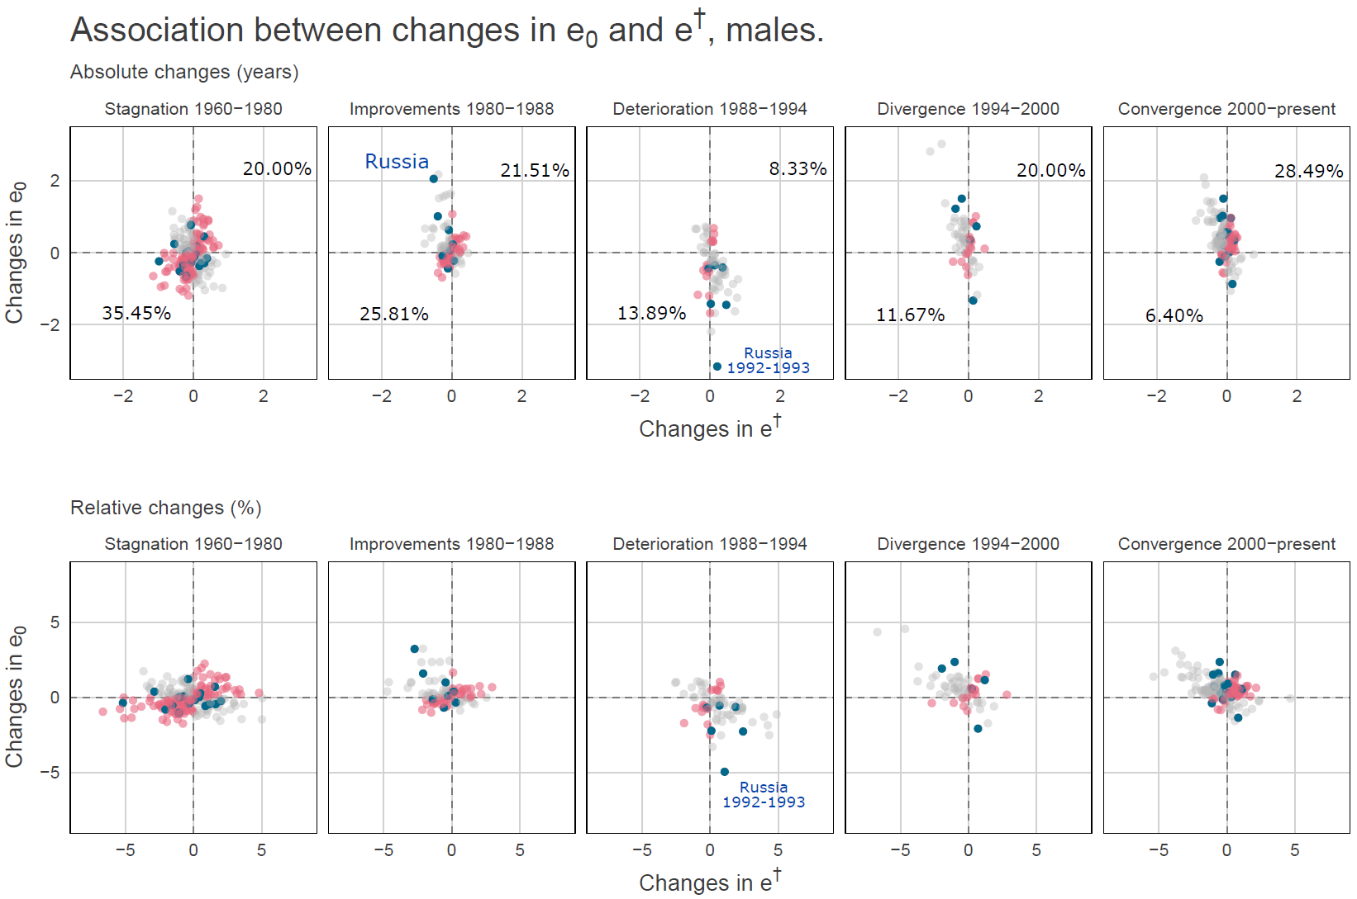

The statistical break points in slope changes in the coefficient of variation for male life expectancy between countries were 1960, 1976, 1986, 1993 and 2001. We instead used complete decades or historical events which made the interpretation of the results easier than having used these exact break points, which were all within 3 years of the cut points. For example, the period 1960-1979 (complete years) included the two decades with no substantial changes in the coefficient of variation between life expectancies. The next break point (1986) was extended to 1988 to include completely Gorbachev’s anti-alcohol campaign, which was implemented in the period 1985-1988. This campaign was an unprecedented effort- in both scale and scope- to control supply and demand of alcohol and, simultaneously raising the effective price of drinking and subsidizing substitutes for alcohol consumption (Bhattacharya et al 2013). Additionally, this campaign was partly the reason of the rise in life expectancy in those years (Leon et al 1997, Bobadilla et al 1997, Cockerman 1999). The following break point was used exactly since it allows the period 1988-1993 to include the dissolution of the Soviet Union in late 1991 and the largest drops in life expectancy in Russia, Latvia, Estonia, Lithuania, and less marked in Ukraine, Belarus, and Bulgaria in 1992-1993 (see Figure 2 in the manuscript and HMD 2018). Finally, the year 2001 was changed to 2000 to start with the 21st century.

We understand the concern about why we did not instead use the (potentially more objective) statistical breaks. To demonstrate that this had little impact on our results, we have recreated the association figure with the statistically determined cut-off periods (see below). Our selection does not change the main results compared with the statistically found ones In addition, we have created an interactive app (<https://demographs.shinyapps.io/CEE_App/>). In this app, the reviewers (and later the readers) can select the years (Association results by period and Decomposition results by period panels) selected statistically (or any combination) and see how sensitive the results are to the selection of the periods. We hope this will alleviate any potential reader concerns that we might have cherry picked dates to strengthen our arguments.

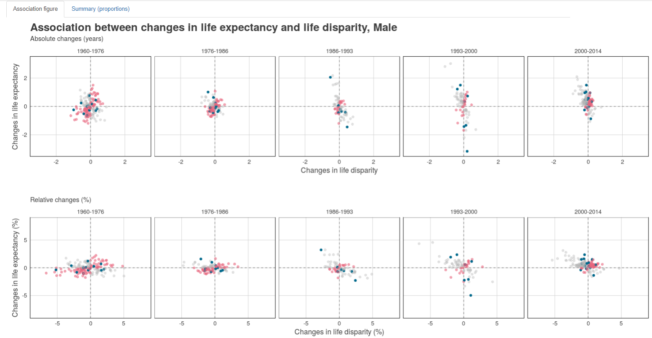Results with statistical break points:

Table. Proportions of changes in life expectancy and lifespan variation in the same and opposite direction, using statistical break points.

|  | **Stagnation 1960-1980** | **Improvements 1980-1988** | **Deterioration 1988-1994** | **Divergence 1994-2000** | **Convergence 2000-present** |
| --- | --- | --- | --- | --- | --- |
| opposite direction (%) | 58.64 | 54.84 | 25.00 | 31.67 | 37.21 |
| same direction (%) | 41.36 | 45.16 | 75.00 | 68.33 | 62.79 |

In addition, we described clearly how the periods were determined in the methods sections. We added the next paragraph:

*“We focused on five periods determined by trends of the coefficient of variation of male life expectancy. from 1960 to 1980 labeled ``Stagnation'', ``Improvements'' from 1980 to 1988, ``Deterioration'' in 1988-1994, ``Divergence between 1994 and 2000, and ``Convergence'' thereafter. Periods were determined using a divisive hierarchical estimation algorithm for multiple change points analysis. The statistical break points were 1960, 1976, 1986, 1993 and 2001. We instead used complete decades or historical events which made the interpretation of the results easier, which were all within 3 years of the cut points. For example, the period 1960-1979 (complete years) included the two decades with no substantial changes in the coefficient of variation between life expectancies. The next break point (1986) was extended to 1988 to include completely Gorbachev’s anti-alcohol campaign, which was implemented in the period 1985-1988. The following break point was used exactly since it allows the period 1988-1993 to include the dissolution of the Soviet Union in late 1991 and the largest drops in life expectancy in Russia, Latvia, Estonia, Lithuania, and less marked in Ukraine, Belarus, and Bulgaria in 1992-1993. Finally, the year 2001 was changed to 2000 to start with the 21st century.”*

References:

Bobadilla, J. L., Costello, C. A., Mitchell, F., & National Research Council (US) Committee on Population. (1997). The Anti-Alcohol Campaign and Variations in Russian Mortality.

Bhattacharya, J., Gathmann, C., & Miller, G. (2013). The Gorbachev anti-alcohol campaign and Russia's mortality crisis. American Economic Journal: Applied Economics, 5(2), 232-260.

Cockerham, W. C. (1999). Health and social change in Russia and Eastern Europe. Psychology Press.

Leon, D. A., Chenet, L., Shkolnikov, V. M., Zakharov, S., Shapiro, J., Rakhmanova, G., ... & McKee, M. (1997). Huge variation in Russian mortality rates 1984–94: artefact, alcohol, or what?. The lancet, 350(9075), 383-388.

Wilmoth, J. R., & Shkolnikov, V. (2008). Human mortality database. University of California, Berkeley (USA), and Max Planck Institute for Demographic Research (Germany).

**The decomposition method should be better explained. It is rather unclear what is the threshold age (mentioned later in results section) which differentiates ages which compress / expand the mortality and how is it computed.**

We added a paragraph explaining with more detail the decomposition method and how the age-cause specific effects between two time points are derived following the line integral model (Horiuchi et al 2008):

“*The decomposition method used in this paper is based on the line integral model (Horiuchi et al 2008). Suppose (e.g. or life expectancy) is a differentiable function of covariates (e.g. each age-cause specific mortality rate) denoted by the vector . Assume that and depend on the underlying dimension , which is time in this case, and that we have observations available in two time points and . Assuming that is a differentiable function of between and , the difference in between and can be expressed as follows:*

*where is the total change in (e.g. or life expectancy) produced by changes in the -th covariate, . The 's in equation (2) were computed with numerical integration following the algorithm suggested by Horiuchi et al (2008). This method has the advantage of assuming that covariates change gradually along the time dimension.*

*We perform such decomposition by single age, period and cause of death..”*

The threshold age is the age at which mortality improvement has no effect on changing life disparity (), and has been taken as the indicator that separates premature and late deaths (Zhang & Vaupel 2009, Vaupel et al 2011). Improvements below this age decrease disparity and improvements above increase life disparity. It exists for several lifespan variation indicators and varies across them (Van Raalte & Caswell 2013). However, it is not fixed and it is different for each country in each time depending on the mortality profile. While presenting results on the threshold age would add unnecessary complexity to an already dense paper, you are right in highlighting that it is necessary to be aware of its existence for interpretation of the age-specific analysis. In figures 4-6, there is a clear break in age-specific patterns (e.g. Russia ages 55-59, Slovakia 65-69, Slovenia 70-74, etc. [see Fig below]), which indicates that around those ages is the so-called threshold age. Its importance relies in the fact that, for example, even though life disparity did not change significantly in the period 1960-1980, when looking at age-specific effects it becomes clear that it was a result of offsetting effects of early and midlife mortality patterns with changes in old age mortality. To clarify what the threshold age is, we have included an explanation in the methods section as a property of :

“*… An important attribute of is the so-called threshold age at which mortality improvements have zero effect on lifespan variation (Zhang & Vaupel 2009). Progress in saving lives below this age reduces variation (also called premature deaths), whereas progress above this age increases variation in lifespans (Vaupel et al 2011).*”

We also explain in the Results section that by visual inspection the threshold age occurs around the age-groups where changes in lifespan variation are usually the lowest in Figures 4-6 (page 9):

“*…The threshold age occurs around the age-groups where changes in lifespan variation are usually the lowest by period (e.g. Russia ages 55-59, Slovakia 65-69, Slovenia 70-74). Bars on the left (decreases in variation) come about from mortality decrease at young ages or increase at old ages, separated by a threshold age. Conversely, bars on the right (increase in variation) are produced by mortality increase at young ages or mortality decrease at old ages…*”

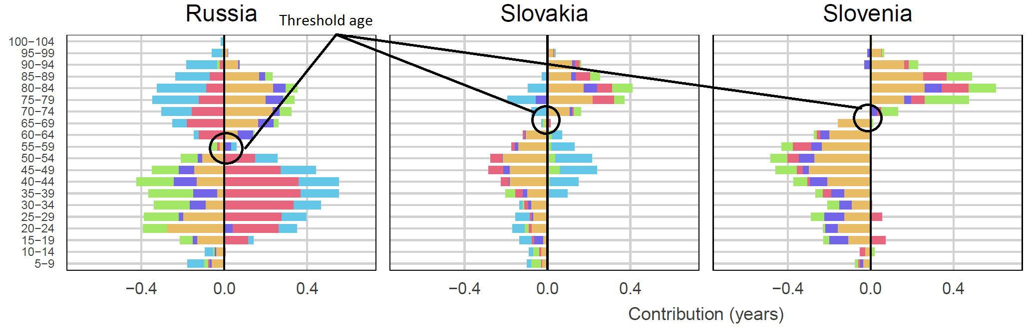

References:

Horiuchi, S., Wilmoth, J. R., & Pletcher, S. D. (2008). A decomposition method based on a model of continuous change. Demography, 45(4), 785-801.

Van Raalte, A. A., & Caswell, H. (2013). Perturbation analysis of indices of lifespan variability. Demography, 50(5), 1615-1640.

Vaupel, J. W., Zhang, Z., & van Raalte, A. A. (2011). Life expectancy and disparity: an international comparison of life table data. BMJ open, 1(1), e000128.

Zhang, Z., & Vaupel, J. W. (2009). The age separating early deaths from late deaths. Demographic Research, 20, 721-730.

**I have a concern regarding the inclusion of infant mortality in the analysis. According to the authors, including infant mortality is important because of its overall impact and because excluding it would require arbitrary censoring of the age scale. Infant mortality in the Eastern countries has however undergone huge artificial changes due to updates of diverse non-standard definitions of live births (which are not corrected in the HMD data). These changes may impact life expectancy and lifespan dispersion differently. Including infant mortality is also in conflict with the aim of the paper, which focuses at adult/elderly mortality and particularly at the effects of alcohol.**

We thank the reviewer for these observations and comments. Eastern European mortality patterns raise questions about quality and completeness of the data. We, however, used the best data available (Human Mortality Database) for the type of analysis that we carried out. As well noticed by the reviewer, a potential concern is the changing definition of live births. Previous studies (Nolte et al 2000a, 2000b) suggest that for Poland, for example, infant mortality could be underestimated due to the definition used prior to 1990 (an effect also found in the former German Democratic Republic). The same happened in other countries from Central Europe and former Soviet countries (Aleshina and Redmond 2003, UNICEF 2003). Although this could affect comparability, we mitigate this by using broad groups, disentangling the effect of infant mortality in figures 1,4-6, and focusing on mortality above age 4. We now mention this in the limitations section.

Taking into account that infant mortality was underestimated before 1990 due to changes in definitions of live births (Aleshina and Redmond 2003, UNICEF 2003), it would bias our results to the extent that lifespan variation would have been larger pre-1989, and declines in lifespan variation would have been more dramatic than observed. More subtly, while the levels would have differed, the trends pre-1990 would have been the same, depending on how much infant mortality is off. Post-1990 there were also differences in the speed of adoption of the WHO rules which could also have led to some biases.

However, we believe that including infant mortality is not in conflict with the aim of the paper. It is true that life expectancy and especially lifespan variation are highly sensitive to changes in early ages in some periods (van Raalte and Caswell 2013), and consequently they have a large impact on the overall level of life expectancy and lifespan variation. By using appropriate decomposition techniques, we could disentangle its effect and analyze age-specific effects above infant mortality. In general, all lifespan variation measures depend on which age is taken as the starting point (Engelman et al. 2010), and we believe that major improvements in very early ages, infant mortality and under five particularly, are undeniable from 1960 in the region (Ahmad 2000) even controlling for the change in definition (Kingkade 2001). Therefore, they should not be overlooked.

To show how sensitive our results are with respect of which age is used as the beginning. we performed a sensitivity analysis with life expectancy and lifespan variation conditional on surviving to age 5 and by doubling infant mortality rates, and included the results in the supplemental material **and a short description in the limitations of the paper**:

*There could be concerns with the quality of the data used in a comparative temporal setting. First, the FSU and Central European countries used a less strict definition of live births from the WHO, which had the result of depressing infant mortality levels (Aleshina and Redmond 2003, UNICEF 2003). Following the transition to market economies, all countries eventually shifted to the WHO definition, although the timing of this shift differed between and within countries (Aleshina and Redmond 2003, UNICEF 2003). Since indices of lifespan variation are comparatively more sensitive to changes in infant mortality than life expectancy (van Raalte and Caswell 2013), we investigated whether our results would be robust to mortality conditional upon survival to age 5 (or to an inflation of IMR before year 1990). While this created some differences in the direction of trends, particularly over the communist period where infant mortality decline was substantial, our two main conclusions from this period still held: (1) life expectancy and life disparity moved independently during the years before the fall of the Berlin wall, (2) trends in life disparity were especially driven by trends in early adult mortality. These results are available in the online Appendix.*

Figure 1 below shows life expectancy at age 5 versus life expectancy at birth for the Eastern European countries selected in our study. Although the level compares with life expectancy at birth differs, major trends look very similar than the ones we show in the paper. For instance, Russia, Latvia and Estonia also show the lower values of life expectancy at age 5, and Slovenia and Czech Republic are the frontrunners in the region after 1990 for males, even without accounting for mortality below age 5

Figure 1. Life expectancy at age 5 for males and females. Source: HMD

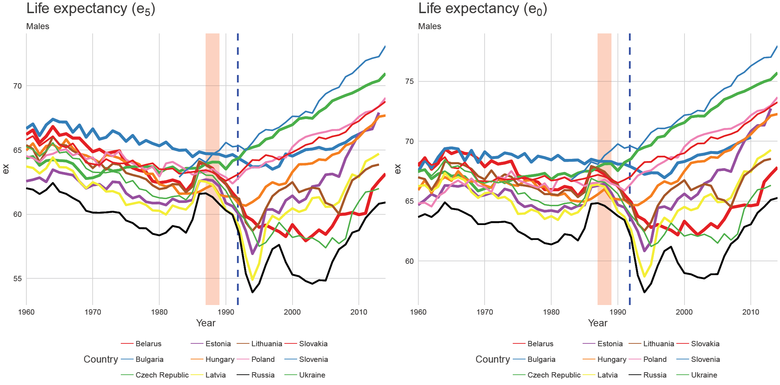

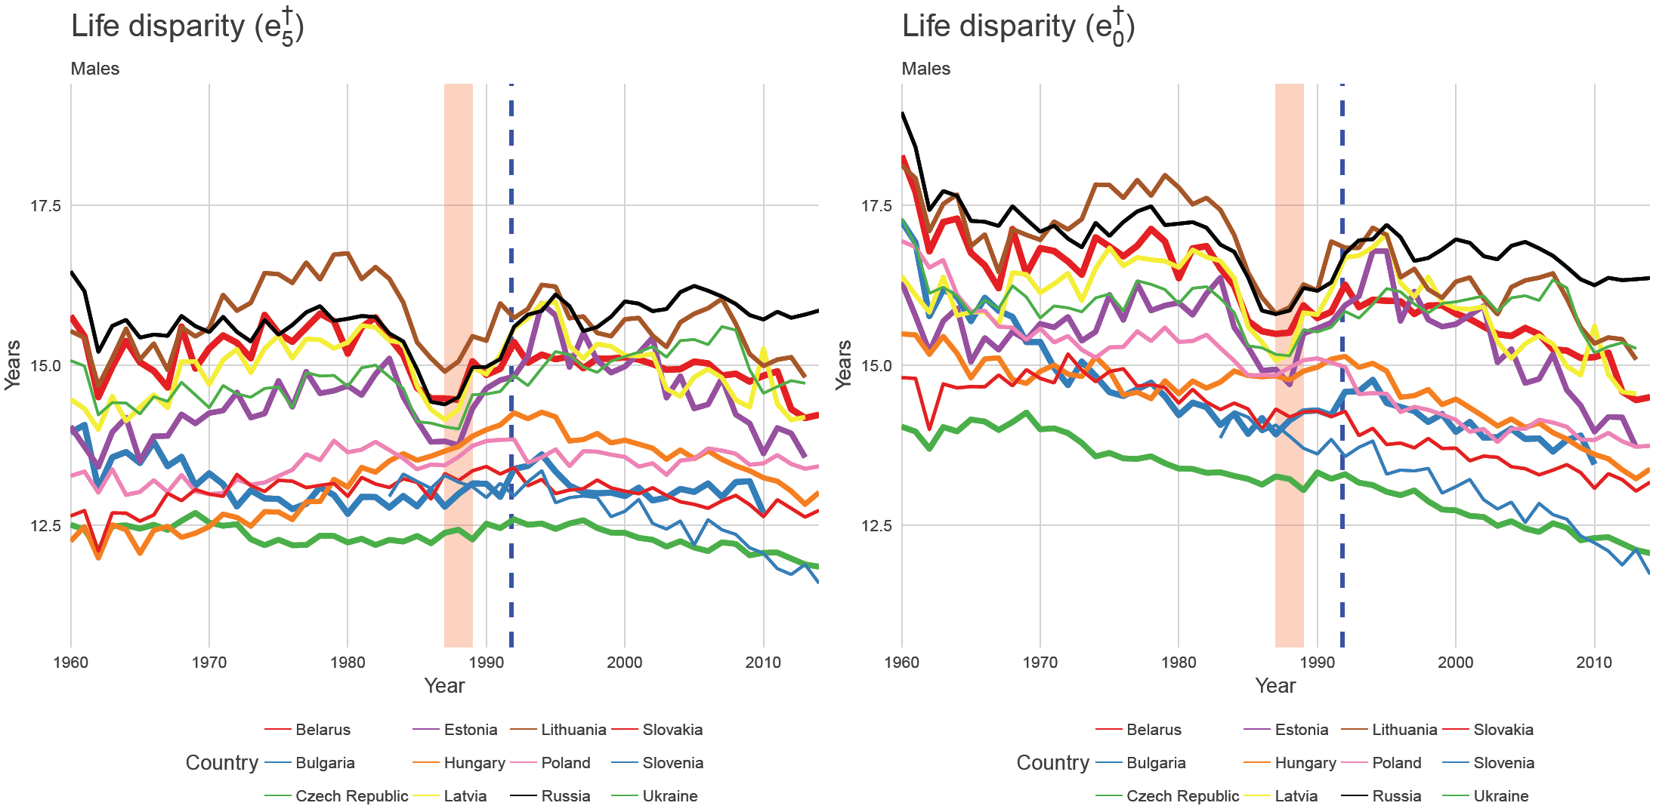Figure 2. Life disparity at age 5 for males and females. Source: HMD

Similarly, Figure 2 shows life disparity or lifespan variation conditional on surviving to age 5 and at birth. As in the previous figure, the trends are very similar to lifespan variation over the full age span. Figure 3 shows the association between changes in life expectancy and lifespan variation conditional on surviving to age 5 and Table 1 shows the proportions of changes in same and opposite directions. The results do not change significantly compared to those including mortality under age 5.

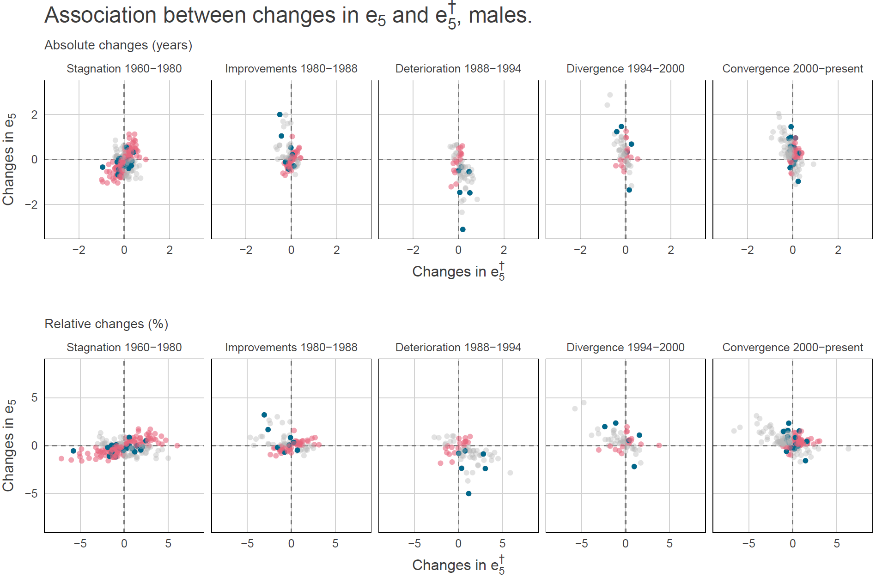Figure 3. Association between changes in life expectancy at age 5 and lifespan variation conditional on surviving to age 5.

Table 1. Proportions of changes in same and opposite direction by period.

|  | **Stagnation 1960-1980** | **Improvements 1980-1988** | **Deterioration 1988-1994** | **Divergence 1994-2000** | **Convergence 2000-present** |
| --- | --- | --- | --- | --- | --- |
| opposite direction (%) | 58.64 | 54.84 | 25.00 | 31.67 | 37.21 |
| same direction (%) | 41.36 | 45.16 | 75.00 | 68.33 | 62.79 |

We further performed the age-specific decomposition of lifespan variation conditional on surviving to age 5 following the same methodology that we used in the paper. Results are shown in Figure 4 below. The results are very close as if we decompose lifespan variation from age 0 (Figure 4 in the paper). We believe the results are the same after age 5 because by ignoring the steep decrease of the probability of dying from age 0 to 5, the age at death distribution starts at values very close to zero. Which would not be the case if we start at age 30 for example, since in this case the distribution would be truncated in the left side (e.g. not starting at values close to zero).

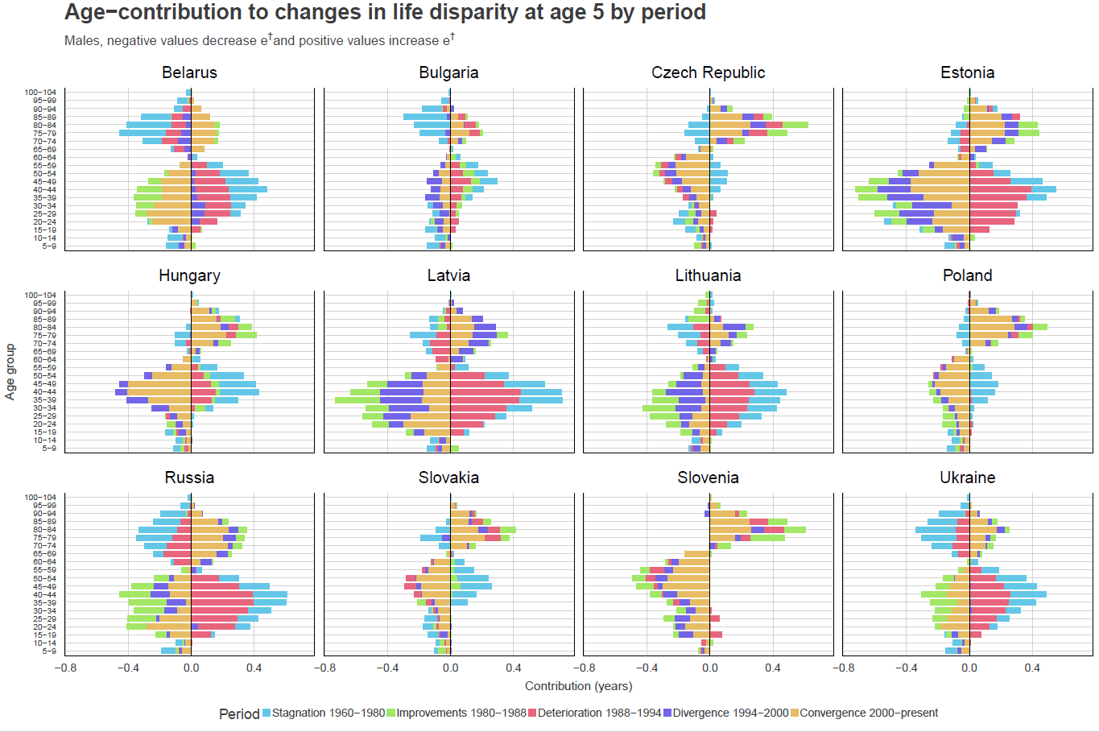Figure 4. Age specific contributions to changes in life disparity conditional on surviving at age 5, by period.

We performed an additional robustness check. We doubled IMRs before 1990, and then a linear decrease towards and inflation of 10% from 2000 onwards. Our results show that even by these drastic assumptions our results would still hold.

Figure 5. Association between changes in life expectancy and lifespan variation doubling infant mortality rates prior to 1990, a linear decrease to 10% higher rates in 2000, and constant inflation of 10% thereafter.

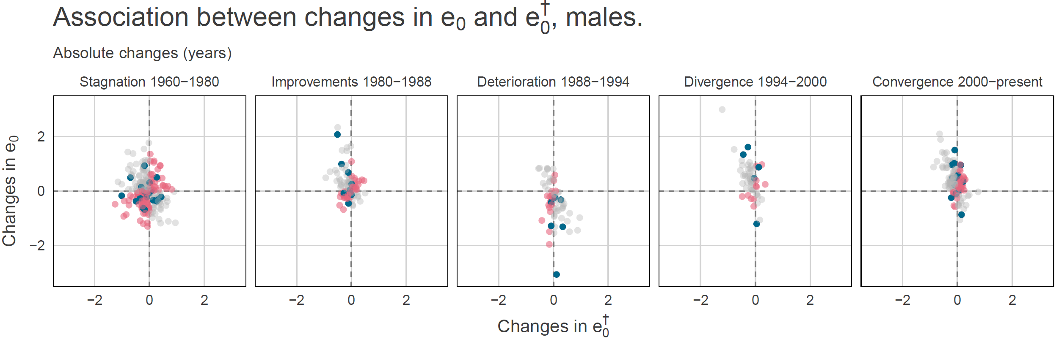

|  | **Stagnation 1960-1980** | **Improvements 1980-1988** | **Deterioration 1988-1994** | **Divergence 1994-2000** | **Convergence 2000-present** |
| --- | --- | --- | --- | --- | --- |
| opposite direction (%) | 47.73 | 48.39 | 27.78 | 21.67 | 34.3 |
| same direction (%) | 52.27 | 51.61 | 72.22 | 78.33 | 65.7 |

**The cause-of-death analysis is too focused on the issue of alcohol. It is of no dispute that alcohol played important role in mortality fluctuations in the period and region of ex-USSR, but it has played much smaller role in central Europe (Poland, Slovakia, Czech Republic). Moreover, these countries have reduced their mortality dramatically after 1990 but the alcohol consumption levels remained the same or even increased, suggesting that alcohol had a very minor role in the recent changes (which were attributed uniquely to progress in cardio-therapy).**

It is true that Central European countries, such as Poland, Slovakia, and Czech Republic, did not experience the large mortality fluctuations that former USSR countries did. These countries did not experience the large changes in alcohol consumption, and therefore the its role is rather small. For instance, it is known that the role of alcohol in Poland, Czech Republic, and other CEE countries, especially those not ex-USSRK, does not explain the decline in mortality from cardiovascular diseases after 1990, but they could be attributed to changes in dietary conditions and improving medical care (Pająk & Kozela 2011, Zatonski 1998). We have improved the discussion section by lessening the role of alcohol consumption on mortality patterns in Central Europe, and mentioning that in these countries the reason of gains in life expectancy and compression of mortality due to cardiovascular conditionsmay be explained by other factors, such as changes dietary habits and improvements in medical care (Zatonski 1998, Pająk and Kozela 2011).

Page 16, paragraph 2: We added: “

References

Ahmad, O. B., Lopez, A. D., & Inoue, M. (2000). The decline in child mortality: a reappraisal. Bulletin of the World Health Organization, 78, 1175-1191.

Aleshina, N., & Redmond, G. (2003). How High is Infant Mortality in Central and Eastern Europe and the CIS?. Innocenti Working Paper No. 76. Florence: UNICEF Innocenti Research Centre.

Cífková, Renata, et al. "Longitudinal trends in major cardiovascular risk factors in the Czech population between 1985 and 2007/8. Czech MONICA and Czech post-MONICA." Atherosclerosis 211.2 (2010): 676-681.

Cooper, R., Schatzkin, A., & Sempos, C. (1984). Rising death rates among Polish men. International Journal of Health Services, 14(2), 289-302.

Engelman, M., Canudas‐Romo, V., & Agree, E. M. (2010). The implications of increased survivorship for mortality variation in aging populations. Population and Development Review, 36(3), 511-539.

Kingkade, W. W., & Sawyer, C. C. (2001). Infant mortality in Eastern Europe and the former Soviet Union before and after the breakup. US Bureau of the Census, Population Division, Washington, DC.

Németh, László. "Life expectancy versus lifespan inequality: A smudge or a clear relationship?." PloS one 12.9 (2017): e0185702.

Nolte, Ellen, Vladimir Shkolnikov, and Martin McKee. "Changing mortality patterns in East and West Germany and Poland. I: Long term trends (1960–1997)." Journal of Epidemiology & Community Health 54.12 (2000a): 890-898.

Nolte, Ellen, Vladimir Shkolnikov, and Martin McKee. "Changing mortality patterns in East and West Germany and Poland. II: Short-term trends during transition and in the 1990s." Journal of Epidemiology & Community Health 54.12 (2000b): 899-906.

Pająk, A., & Kozela, M. (2011). Cardiovascular disease in Central and East Europe. Public Health Reviews, 33(2), 416.

Rychtarikova, J. (2004). The case of the Czech Republic: Determinants of the recent favourable turnover in mortality. Demographic Research, 2, 105-138.

Unicef. (2003). Social monitor, 2003.

Van Raalte, A. A., & Caswell, H. (2013). Perturbation analysis of indices of lifespan variability. Demography, 50(5), 1615-1640.

Zatonski, W. A., McMichael, A. J., & Powles, J. W. (1998). Ecological study of reasons for sharp decline in mortality from ischaemic heart disease in Poland since 1991. Bmj, 316(7137), 1047.

**It is also quite problematic to separate the rest of circulatory diseases from IHD and stroke, as it is known, that many Eastern countries code a large part of IHD or stroke as „atherosclerosis“.**

Regarding the cause-of-death analysis. It is true that deaths from hypertension and atherosclerosis could be overestimated at the expense of ischemic heart disease mortality in some countries and time periods, such as Poland before 1991 (Cooper et al 1984, Zatonski 1998). However, death certification rates showed decreases in both ischemic heart diseases (IHD) and atherosclerosis, suggesting that the decline in mortality from IHD was unlikely due to changes in coding practices after 1991. Since our analysis on causes of death is focused from 1994 onwards to have comparability between a set of countries, the change in coding practices is unlikely to influence the estimates that we show (Zatonski 1998). (Jasilionis et al 2011, Shkolnikov et al 2012). In light of this evidence, we have decided to group IHD, stroke, and the rest of cardiovascular diseases to a single category ‘amenable to alcohol consumption’. Which we explicitly describe as “*…conditions amenable to alcohol consumption, pertains to conditions that are not wholly attributable to alcohol consumption, but that have been linked with alcohol consumption patterns.”* in the cause-of-death classification section. We now describe the cause of death classification and table 1 accordingly, and extended this to the results and discussion section.

. \\

.

References:

Pechholdová, M., Camarda, C. G., Meslé, F., & Vallin, J. (2017). Reconstructing Long-Term Coherent Cause-of-Death Series, a Necessary Step for Analyzing Trends. European Journal of Population, 1-22.

**In the decomposition analyses (by age), it is likely that positive contributions of the elderly to the mortality compression can be linked to poor data quality in the ex-USSR and Bulgaria in the 1960s (underestimation of old-age mortality leading to artificial worsening afterwards). This should be mentioned in the discussion/limitations.**

We thank the reviewer for this suggestion. This issue is mitigated using the Human Mortality Database, since they correct the lifetable at old age fitting a logistic curve. In figure 4 in the manuscript, Bulgaria shows the opposite: it shows mortality deterioration above age 70 between 1960 and 1980 (blue color, fig below), which was translated into reductions in lifespan variation (since these changes are above the threshold age) and improvements thereafter with mixed patterns between 1994-2000. All countries show this pattern between 1960 and 1980 (except Slovenia since we don’t have data).

We included the next sentences in the limitations section:

*“Finally, different definitions of live births, coding practices and under-registration at old ages in former USSR countries are an issue in the mortality data….* *Moreover, we mitigated this by truncating our cause-of-death analysis at age 85 and using comparable data from the Human Cause-of-Death and Human Mortality databases”*

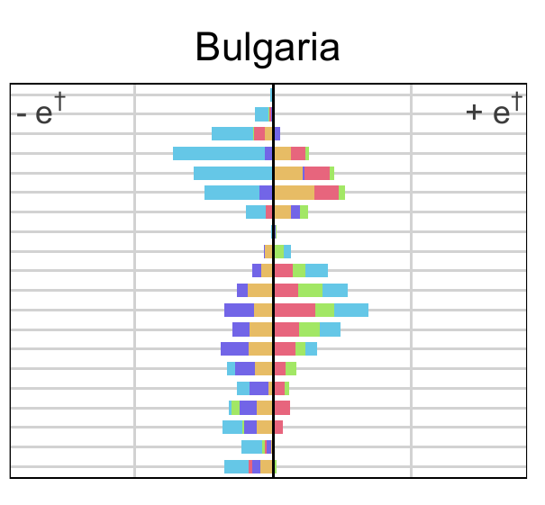

**In the Limitations section, the author discusses several approaches to the measurement of alcohol mortality effects. This limitation could be avoided if authors gave less importance to the alcohol as the main (and only) factor for past and recent mortality changes in Central and Eastern Europe.**

We thank the reviewer for her/his suggestion. Although we believe that categorizing alcohol-related mortality has several limitations, explained in the manuscript, we did changes to the manuscript to explicitly add other explanations to past and recent mortality changes in Central and Eastern Europe. The changes were as follows:

Abstract. We change *“Fluctuations in mortality were, to a large extent, directly or partially attributable to changes in alcohol consumption.”* by *“Fluctuations in mortality were, to a large extent, directly or partially attributable to changes in deaths related to alcohol consumption, among other factors.”*

Cause-of-death subsection in discussion:“*Fluctuating alcohol-related mortality was an important component of the moving life disparity trends in the wider region, although it occurred to different degrees and manifested itself in different causes over the period and in the different regions. Over young ages, a large role was found for the reduction of external cause mortality including traffic accidents in the Baltic countries throughout the period, and in Russia, Belarus and Ukraine from 2000 onwards, whereas Czech Republic and Poland reduced mortality primarily through reductions in IHD, and non-alcohol related mortality. Moreover, in Poland and Czech Republic, the reason of gains in life expectancy and compression of mortality due to the decline in stroke and IHD may be explained by other factors other than alcohol patterns (Pajak 2011), such as changes dietary habits (Zatonski et al. 1998). At older ages, between-country differences in mortality reduction seemed to be driven by the extent of IHD and stroke mortality reduction.*”

"*Overall, alcohol-related mortality (both increases and reductions) had its strongest influence in Russia, Latvia, Lithuania and Estonia, particularly over young-adult ages; while in the rest of the countries, Ukraine, Poland, Belarus and Czech Republic the effect of alcohol-related mortality on changes in lifespan variation was less clear. This is consistent with previous research documenting the highest impact of alcohol consumption on premature adult mortality in Russia, and considerable less in Poland and Czech Republic in 2002.”*

*“…In addition, alcohol consumption is not the only factor that explains mortality trajectories in the region, or the difference between life expectancy and lifespan variation levels with western European countries. Other factors, such as environmental pollution, medical care, smoking behaviors and diet are important determinants of health outcomes in this region at least since 1970 (Bobak and Marmot 1996)”*

Discussion. In order to downplay the examination exclusively of alcohol-attributable mortality, we replaced the sentences: “we used high quality comparably reconstructed cause of death data to analyze the role of alcohol-related mortality on changing lifespan variation based on a reflective classification” with:

“we looked into the causes of death that were responsible for the major changes in lifespan variation in the region.”

References added

Bobak, M., & Marmot, M. (1996). East-West mortality divide and its potential explanations: proposed research agenda. BMJ: British Medical Journal, 312(7028), 421.

Pająk, A., & Kozela, M. (2011). Cardiovascular disease in Central and East Europe. Public Health Reviews, 33(2), 416.

Rehm, J., Sulkowska, U., Mańczuk, M., Boffetta, P., Powles, J., Popova, S., & Zatoński, W. (2007). Alcohol accounts for a high proportion of premature mortality in central and eastern Europe. International journal of epidemiology, 36(2), 458-467.

Shkolnikov, V., Meslé, F., & Vallin, J. (2012). Data Collection, Data Quality and the History of Cause-of-Death Classification. In Mortality and Causes of Death in 20th-Century Ukraine (pp. 121-130). Springer, Dordrecht.

Zatonski, W. A., McMichael, A. J., & Powles, J. W. (1998). Ecological study of reasons for sharp decline in mortality from ischaemic heart disease in Poland since 1991. Bmj, 316(7137), 1047.

**I would like to see a bigger discussion on the added value of the lifespan dispersion indicators. It seems that if lifespan inequality is measured across the entire age range, its value depends on two processes: premature and old-age mortality, and mortality compresses or expands when these two processes move in opposite directions (and how they balance in the summary measure). The allegedly unexpected results for Central and Eastern Europe are thus rather witnesses of different sensitivity of e0 and e-dagger to mortality age-patterns.**

In page 14, we complemented the paragraph preceding the age-specific contributions to stress the added value of lifespan variation as an indicator in population health studies. It now reads:

*“From a public health perspective, these results are important because they disclose inequalities underlying population health that could not be identified by looking at life expectancy alone. As previously noted, the full distribution of deaths is characterized not only by the mean (life expectancy), but also by how disperse ages at death are (Edwards and Tuljapurkar 2005). Therefore, increasing lifespan variability underscores the rise in within-group heterogeneity and the uncertainty that people face regarding their age at death.”*

We complemented the concluding paragraph and now the first two sentences read:

“*Lifespan variation, in this case , is a measure of aggregate health inequality that reveals fundamental differences in levels and trends across the countries that we studied. Therefore, analyzing lifespan dispersion together with life expectancy contributes to a deeper understanding of the impact of changing mortality trends on population health…”*

We also include a subsection in the discussion named “Age-specific contributions to changes in ", in this subsection we included the next sentence:

“*Life expectancy increases with mortality improvements at all ages. However, lifespan variation increases or decreases depending on the balance of saving lives at ``younger ages'', which compresses mortality into a smaller age interval and at ``older ages'' where saving lives leads to greater variability (Zhang and Vaupel 2009, Gillespie et al. 2014). These properties indicate that life expectancy and lifespan variation have different sensitivities to mortality changes over the age-span (van Raalte and Caswell 2013). Thus, lifespan variation, when measured across the entire age range, depends on two processes: premature and old-age mortality. Mortality compresses or expands, depending on the balance between these two processes. Our results for Central and Eastern Europe, which run counter the western narrative, are a product of different sensitivity of life expectancy and lifespan variation to mortality age-patterns.* ”

References

Edwards, R. D., & Tuljapurkar, S. (2005). Inequality in life spans and a new perspective on mortality convergence across industrialized countries. Population and Development Review, 31(4), 645-674.

Tuljapurkar, S. (2010). The final inequality: variance in age at death. In Demography and the Economy (pp. 209-221). University of Chicago Press.

Zhang, Z., & Vaupel, J. W. (2009). The age separating early deaths from late deaths. Demographic Research, 20, 721-730.

Gillespie, D. O., Trotter, M. V., & Tuljapurkar, S. D. (2014). Divergence in age patterns of mortality change drives international divergence in lifespan inequality. Demography, 51(3), 1003-1017.

Van Raalte, A. A., & Caswell, H. (2013). Perturbation analysis of indices of lifespan variability. Demography, 50(5), 1615-1640.

**Reviewer 2**

**The analysis is quite comprehensive, and done carefully. The methods and technical details of the analysis seem appropriate.**

Thank you

**But I don't think some interesting and important results are properly highlighted or summarized. The abstract states: "Our results showed that life disparity was high and strongly fluctuating over the time period. Life expectancy and life disparity moved independently from one another, particularly during periods of life expectancy stagnation." This is a fairly "plain" description of the results, missing some interesting patterns identifiable in the results.**

We …..

**In the results, e0 and e† do not look independent, but are negatively associated for 1988-1995 and 1996 onwards. (Since e0 was fairly stationary for 1960-1987, the association could not be strong in that period anyway.) The decomposition analysis indicates that much of the changes in e† are attributable to increases and decreases (recovery form increase) in middle-age (and younger old-age) mortality, particularly for males in the former USSR countries. This is an interesting result, which should be more highlighted. Also this makes a sharp contrast with typical patterns observed in "Western" countries, which went through two stages, increases in lifespan and decreases in dispersion up to around 1970, driven mainly by reduction in young-age mortality, and increases in lifespan and small increases in dispersion after around 1970, driven by the shift of high mortality to older ages. The West versus East differences are mentioned, but should be made clearer and summarized better.**

One major reason why lifespan inequality is rarely tracked is because of the high negative correlation with life expectancy. There is of course no reason why that needs to be the case, and we found it striking that for nearly 30 years the two measures moved in the same direction more often than in different directions. To our knowledge this has never been shown empirically before, and we consider it a major finding from this analysis worthy of being highlighted. While it is true that the overall trends were flat, as you point out, the year-to-year differences were up to 2% in e0 and up to 5% in e†, so not always inconsequential. Nevertheless, it’s an important point that the two measures were negatively correlated after 1988, when yearly mortality change was on average larger. So we have to be careful not to oversell the independence argument. As we see it, the main difference from before and after 1988 was that in the earlier periods age-specific trends were moving in opposite directions. Afterwards, through both periods of crises and recovery, age-specific trends tended to move in the same direction at all ages (with younger ages being the strongest drivers), which explains why the e† and e0 relationship resumed being negatively correlated.

To make the above clear, we reframed all of this within the context of typical ‘Western’ patterns versus the anomylous Eastern age-specific mortality change, highlighting the different age-specific mortality trajectories as you suggested above. We made the following changes:

Changes to the Abstract:

…Generally life disparity was high and strongly fluctuating over the period. For nearly 30 of these years, life expectancy and life disparity moved independently from one another, largely because mortality trends ran in opposite directions over different ages. …Mortality patterns in CEE countries were heterogeneous and run counter to the common patterns observed in most developed countries.

Changes to the Discussion

- still needs to be written…

**Also, it will help readers if the 12 countries are distinctly split into two or three subgroups based on their differential patterns of time trend in e0 and e† and if the grouping is used consistency throughout the paper.**

As reviewer 3 also suggested, as far as possible we grouped our discussion around three main groupings that experienced more similar trends: Central Europe + Bulgaria, the Baltic Countries, and other FSU countries. We hope that this patterning helps to anchor the trajectories geographically and has livened up some of the more dense sections of the paper.

In addition we recreated all decomposition figures in concordance with the grouping by adding a specific label and background color in each country.

**A minor comment. I felt that the term "fluctuation" was overused in this paper. For example, changes in e0 and e† due to the anti-alcohol campaigns and those around the USSR dissolution are systematic changes due to identifiable, solid reasons. They seem too strong and too clear to be called "fluctuations".**

That’s true. We tried as much as possible to avoid strong normative wording, but these mortatity changes were objectively massive by any definition. To better convey this, we:

Introduction: “Since the ‘sharpest fluctuation’ in age-specific mortality occurred over working ages…” changed to “Since the ‘largest deviations’ in age-specific mortality occurred over working ages”

-

Data and Methods: “Mortality fluctuated more strongly among men” changed to “Mortality change was larger and more abrupt among men”

**-**

**…**

**Reviewer 3**

**This is an important paper focusing on lifespan variation in the Central and Eastern European countries with their abnormal changes in life expectancy in the second half of the 20th – beginning of the 21st centuries. It explores the age- and cause-specific changes in lifespan disparity at different periods of life expectancy change.**

**Hope that my further comments would be useful in improving the manuscript.**

Thanks for the careful reading and suggestions. Below are the changes/responses to the comments.

**The introduction part is a little bit messy. The description of well-known trends in life expectancy in CEE is not structured enough. I would recommend referring to three groups of countries within CEE – Central Europe, Baltic States and Former USSR (something like this). Besides that, it seems strange to paste the key findings at the end of introductory part.**

as far as possible we grouped our discussion around three main groupings that experienced more similar trends: Central Europe + Bulgaria, the Baltic Countries, and other FSU countries. We hope that this patterning helps to anchor the trajectories geographically and has livened up some of the more dense sections of the paper.

In addition we recreated all decomposition figures in concordance with the grouping by adding a specific label and background color in each country.

The text containing the main findings at the end of the introduction was deleted from this section and merged with the first paragraph of the discussion to highlight the main contribution of the study. It now reads:

“… *Over the study period, the acute mortality crises of the 1990s caused greater year-to-year fluctuation in lifespan variation than in life expectancy. Life expectancy and life disparity moved independently from one another, particularly during periods of life expectancy stagnation caused by uneven age-specific mortality change. Fluctuations in life disparity were, to a large extent, caused by fluctuation in mid-life mortality that was directly or partially attributable to mortality amenable to alcohol consumption, with different net effects depending on the country and time period.*”

**In the methodology part, the authors do explain the choice of e-dagger measure and provide the sensitivity analysis of other measures of lifespan inequality. However, it seems that for the reader it would be more useful to have the discrete formulae of e-dagger and its age-and cause-specific decomposition used in this paper.**

Regarding the decomposition, we added a paragraph explaining with more detail the decomposition method and how the age-cause specific effects between two time points are derived following the line integral model (Horiuchi et al 2008). In addition, we added a footnote with our discrete formula for e-dagger.

“*The decomposition method used in this paper is based on the line integral model (Horiuchi et al 2008). Suppose (e.g. or life expectancy) is a differentiable function of covariates (e.g. each age-cause specific mortality rate) denoted by the vector . Assume that and depend on the underlying dimension , which is time in this case, and that we have observations available in two time points and . Assuming that is a differentiable function of between and , the difference in between and can be expressed as follows:*

*where is the total change in (e.g. or life expectancy) produced by changes in the -th covariate, . The 's in equation (2) were computed with numerical integration following the algorithm suggested by Horiuchi et al (2008). This method has the advantage of assuming that covariates change gradually along the time dimension.*

*We perform such decomposition by single age, period and cause of death..”*

**I guess that the choice of the periods for analysis (stagnation, improvement, deterioration, divergence and convergence) should be discussed more and in the methodology section. I am not sure that the last period of convergence started in 2000. A little bit later?**

In addition, we described clearly how the periods were determined in the methods sections. We added the next paragraph:

*“We focused on five periods determined by trends of the coefficient of variation of male life expectancy. from 1960 to 1980 labeled ``Stagnation'', ``Improvements'' from 1980 to 1988, ``Deterioration'' in 1988-1994, ``Divergence between 1994 and 2000, and ``Convergence'' thereafter. Periods were determined using a divisive hierarchical estimation algorithm for multiple change points analysis. The statistical break points were 1960, 1976, 1986, 1993 and 2001. We instead used complete decades or historical events which made the interpretation of the results easier, which were all within 3 years of the cut points. For example, the period 1960-1979 (complete years) included the two decades with no substantial changes in the coefficient of variation between life expectancies. The next break point (1986) was extended to 1988 to include completely Gorbachev’s anti-alcohol campaign, which was implemented in the period 1985-1988. The following break point was used exactly since it allows the period 1988-1993 to include the dissolution of the Soviet Union in late 1991 and the largest drops in life expectancy in Russia, Latvia, Estonia, Lithuania, and less marked in Ukraine, Belarus, and Bulgaria in 1992-1993. Finally, the year 2001 was changed to 2000 to start with the 21st century.”*

**Data from HMD for 12 countries and HCoD for 8 countries are used. Is it impossible to get the rest cause-specific data from the WHO mortality databases? I realize that it is much more convenient and reliable to get the data from the “scientific” databases where all the data are checked for their consistency. But I believe that the authors could obtain the data from the WHO mortality databases as well or at least to discuss why it is impossible to use those data for 4 countries that are not covered in HCoD.**

We followed the reviewer’s suggestion and analyzed data from WHO for Bulgaria, Hungary, Slovakia and Slovenia. All except one (Slovakia) experienced the change from ICD9 to ICD10 in the period studied in the manuscript from 1994 to 2010. Bulgaria started coding deaths with ICD10 in 2005, Hungary in 1996, and Slovenia in 1997.

There are several limitations of using WHO data for alcohol related mortality in this set of countries. Firstly, deaths coded with ICD9 (Table 5. ICD9-9 from WHO documentation) are not sufficiently disaggregated to analyze some of the specific causes of death that we are interested in. For example, the codes that in ICD10 (F10) account for deaths due to alcohol psychosis, alcohol abuse, and alcohol dependence syndrome in ICD9 are 291, 305.0, 303.0, 303.9. However, 291 is grouped in the category of other psychoses (codes 291-294, 297-299) in WHO data, 305 is not available and the rest are grouped in 303 (we use this group for our analysis in this section). Similarly, deaths caused by poisoning by exposure to alcohol (X45 in ICD10) are not ungrouped in the WHO data, all of them (E860.0, E860.1, E860.2 and E860.9) are in the category “Accidental poisoning by other solid and liquid substances” which includes E860-E866, and 980.0, 980.1 and 790.3 (Excessive blood level of alcohol) do not appear in the list. The bridge codes were taken from the Center for Disease Control and Prevention from USA.

As noted above the relationship ICD codes when changing revisions is very complex for a large number of conditions. Consequently, various levels of the classification (e.g. alcohol related mortality) do not reflect actual long-term trends in mortality. Moreover, available raw data cannot be used to draw any conclusions about patterns without a thorough analysis of the quality of the data (Vallin et al. 1988). In order to stablish comparable continuous time series on causes of death it is necessary to reconstruct mortality trends, assess the statistical impact of changes of coding practices, and a automatized routine that allows to compare between countries described elsewhere (Pechholdová et al 2017).

An additional limitation is the completeness of the data. WHO recovers data from statistical offices without any assessment of completeness. For instance, Hungarian data do not show any information on some causes of death after 1996, while for others there is a complete time series.

We mitigate the issue of ICD comparable information using the recently published Human Cause of Death Database (HCoD). This database performed quality checks and reconstructed mortality trends for the countries showed in the manuscript following Pechholdová et al (2017) when needed. Further, to mitigate the completeness limitation, we use the HCoD’s cause of deaths structure and applied it to the mortality rates in the HMD.

To show these limitations, we did a country-specific analysis with this information to decide whether the data was reliable enough to include the country in the manuscript for the cause-of-death analysis. We additionally created an interactive app to analyze the results in the panel ‘Rupture analysis’ at <https://demographs.shinyapps.io/CEE_App/>. A summary of these analyses is below.

Bulgaria: Stroke and Other circulatory categories show a clear rupture in the year when ICD changed. This rupture suggests that they complement each other. Grouping all cardiovascular (i.e. IHD, Stroke and Other circulatory) could make comparable the trends. However, infectious and respiratory diseases also show clear change in trends after ICD 10 was implemented, and it is not clear which category was accounting for these conditions before that period.

Hungary: Missing information for most of the years and causes of death. Bad and problematic data overall.

Slovakia: It uses ICD10 throughout the entire period. There is a strange trend in Infectious and respiratory diseases in the late 1990s. In the rest in recent years, and it seems that Stroke and Other circulatory complement each other.

In light of the above, we decided not to include WHO data in our study.

References:

Center for Disease Control and Prevention. Alcohols and Public Health: Alcohol-related disease impact (ARDI). Visited on 08/02/2018. <https://nccd.cdc.gov/dph_ardi/Info/ICDCodes.aspx>

Pechholdová, M., Camarda, C. G., Meslé, F., & Vallin, J. (2017). Reconstructing Long-Term Coherent Cause-of-Death Series, a Necessary Step for Analyzing Trends. European Journal of Population, 1-22.

Vallin, J., Meslé, F., Caselli, G., & Egidi, V. (1988). Les causes de décès en France de 1925 à 1978 (Vol. 1). Ined.

**The choice of the groups of causes of deaths is fully relied on the papers by Rehm et al. that is not convincing enough especially when second and third categories are identified. For examples, epidemiological studies by David Leon et al. and by David Zaridze et al. show relative risks associating alcohol consumption with cause-specific mortality in Russia. I believe that similar studies were also held in other CEE countries. The results of these studies could strengthen the cause of deaths classification used in this paper.**

**The authors state that they aim to identify the effect of mortality related to alcohol consumption on lifespan variation from 1994 to 2010. Why this particular period was chosen?**

Two reasons: data availability and trends before 1994 have been studied

**Minor comments:**

1. **Mortality increase in CEE countries started not in 1960 but since the mid-1960s**
2. **“larger mortality inequalities in this region compared with western countries in Europe”. I am not sure about that. Timonin et al showed that the disparities between western European countries are larger than the disparities between CEE.**
3. **I have not really understood why such cause of death as “birth conditions” is used in the figure 5.**

**Finally, are there any ideas why life disparity has been stagnating in Russia since 2010?**